Automated Color Recognition System using Arduino and Mobile App

In the studies, it is identified that color plays a vital role in human daily life for recognition. The main objective is to develop a prototype which can detect different colors and display on LCD and android phone. This system is implemented on Arduino microcontroller with android device in which color Recognition can be done. The project is based on both hardware and software. This project uses Bluetooth Module that connects the hardware with a Mobile device. The software used in the project is Arduino IDE which is used for coding and as an interface between Arduino microcontroller and Mobile App.
This model includes Mobile App with the hardware components such as Arduino microcontroller, Color Sensor, and Bluetooth Module. Arduino microcontroller atmega328 is used to implement thisproject. The proposed system works in standalone mode without the necessity of PC once it is programmed. We used the rapid prototype technique approach of a color object for real-time applications using Arduino support package meant for Arduino microcontroller.

Software:
- ARDUINO IDE
- EMBDDED CPP CODE
- PROTEUS SIMULATOR
Hardware :
- Arduino Microcontroller
- Color Sensor Module TCS3200
- Bluetooth Module
- LCD DISPLAY

BLOCK DIAGRAM:

LCD DISPLAY

MCU

Color Sensor Module
TCS3200

BLUETOOTH MODULE

RECEIVER
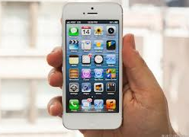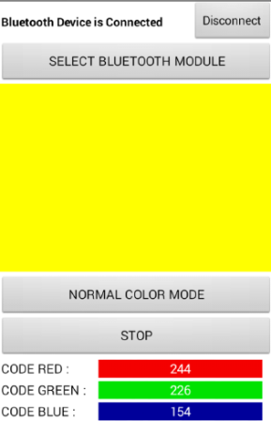
(ANDROID PHONE)

