AGROBOT DESIGNED AS PLANT WATERING SYSTEM

Many advances in technology have made the agriculture business a much less labor intensive industry to be a part of. If we think back even only 50 years, farmers were just beginning to incorporate technologies into their farming techniques. It has been said that individuals that are involved in the farming industry are some of the least susceptible to change. They are very set in the ways of those came before them. When we take a look at the farming industry now, we can see that this is rapidly changing. Farmers are looking for new ways to implement technology to cut costs and reduce labor hours.
One of the ways that farmers are beginning to explore new technologies in farming come from the RF tractor. This is something new to the agriculture industry, but is quickly gaining popularity from agriculture research companies around the country. These tractors are described by Farm Industry News as a tractor that drives its solve with a computer in control. Although still in the research phase of development, RF tractors are rapidly becoming more of a reality than an idea.
The tractor is controlled by a RF remote. This can be moved forward and reverse direction using DC motors. Also this robot can take sharp turnings towards left and right directions.
Most of the cases the things done during farming are plough, watering and seeding. For performing all these operations lot of manpower is needed. So, by using RF tractor all these things can be done with ease. Without much manual effort, by simply pressing switch using RF remote corresponding action can be performed. The RF modules used here are Transmitter, Receiver, RF Encoder and RF Decoder. The switches are interfaced to the RF transmitter through controller. The encoder continuously reads the status of the switches through controller and passes the data to the RF transmitter and the transmitter transmits the data. This project uses 12V battery.

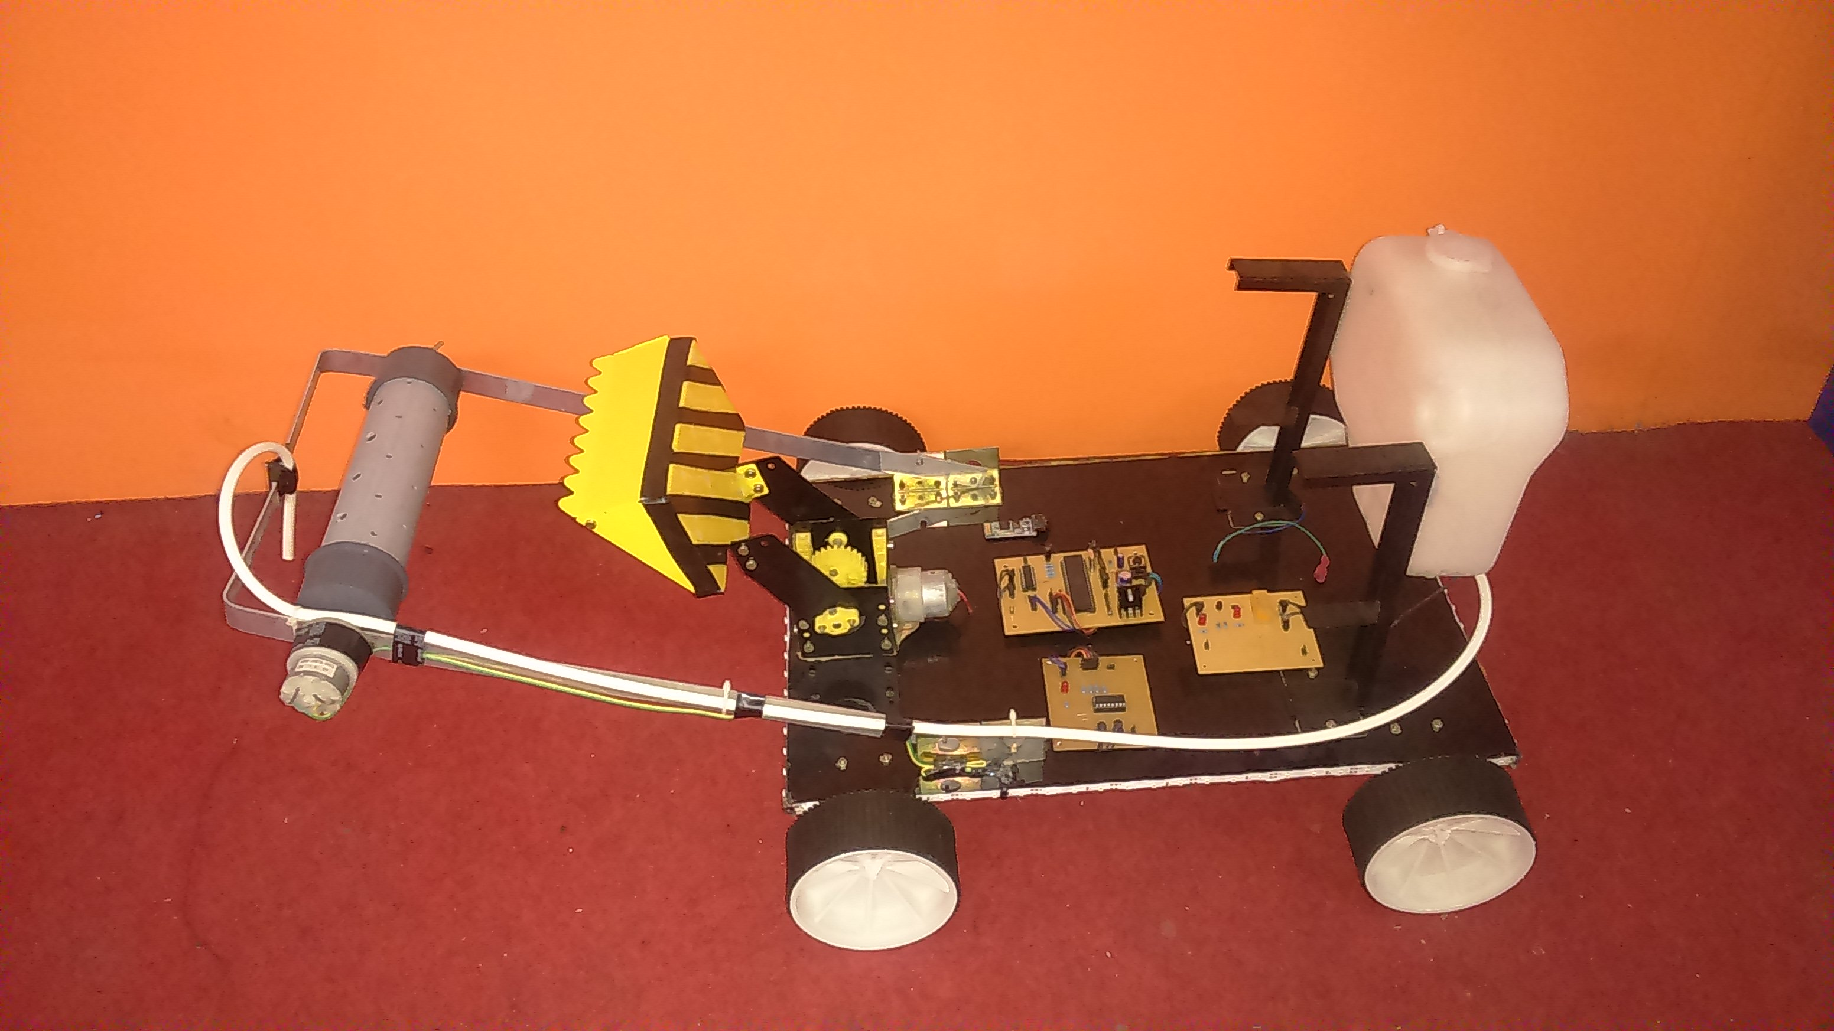
Block Diagram: Transmitter:
Power supply

Micro
Controller

Switch array
RF Transmitter
RF Encoder
Reset

Crystal oscillator

Receiver:
DC
Motor - I

Micro
Controller

H-Bridge

RF Decoder
DC
Motor - II

RF Receiver

Water
Sprinkler

Relay

Automatic ploughing

H-Bridge
DC
Motor
Gearing Mechanism
Reset
Crystal oscillator

DC
Motor
Automatic seeder

