A Very Simple User Access Control Technique through Smart Device Authentication using Bluetooth Communication

ABSTRACT

Large scale adoption of smart devices like smart mobile phones for personal usage has opened up an opportunity to identify individuals via their smart device identities. This paper aims to achieve very simple technique of user’s access control through device authentication using a microcontroller board such as Raspberry Pi that interacts with the smart device using Wi-Fi or Bluetooth technology which is almost available in every smart device. The implementation procedure is discussed through the experimentation. As a methodology of secured communication, password protection is used in the mobile apps. Some possible application areas are discussed in which the proposed methodology may be applied to enable appropriate services. The novelty of this work is to provide a simple and low cost solution for user’s access in a secured protected place. Further, the proposed authentication mechanisms are intuitive and require minimum effort.

Existing System:
In the existing approach, a very simple mechanism of user’s access control via smart mobile device authentication is discussed. A model has been implemented using Bluetooth communication and Arduino microcontroller Board, which is very low end controller, less processing speed and can run only single task at a time.
Proposed System:
The proposed system will be implemented on a Linux based device of ARM 11 architecture which includes the multitasking of the applications will be achieved. Here will be access the device using Bluetooth as well as Ethernet (Wi-Fi) to transmit the data to the board, which will acquire it and display the same on the LCD.

BLOCK DIAGRAM
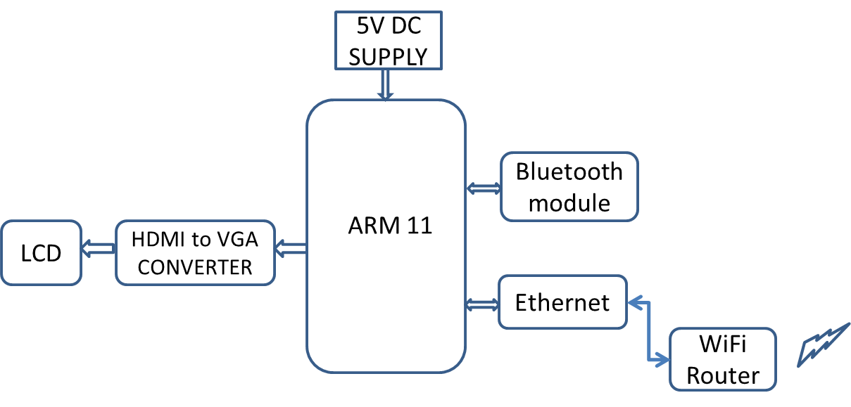
Software: Linux OS, C/C++,Qtopia
Hardware:
ARM11 (Raspberry Pi), GSM, Bluetooth module, HDMI to VGA converter.
Applications:
Web based results, University place, colleges, and museum.
Advantages:
Low Power consumption, Speed Process

