A Reconfigurable Smart Sensor Interface for Industrial
WSN in IoT Environment

ABSTRACT

A sensor interface device is essential for sensor data collection of industrial wireless sensor networks (WSN) in IoT environments. However, the current connect number, sampling rate, and signal types of sensors are generally restricted by the device. Meanwhile, in the Internet of Things (IoT) environment, each sensor connected to the device is required to write complicated and cumber some data collection program code. In this paper, to solve these problems, a new method is proposed to design a reconfigurable smart sensor interface for industrial WSN in IoT environment, in which ARM 11 chip is adopted as the core controller. Thus, it can read data in parallel and in real time with high speed on multiple different sensor data.
It comprehensively stipulates the smart sensor hardware and software design framework and relevant interface protocol to realize the intelligent acquisition for common sensors. A new solution is provided for the traditional sensor data acquisitions. The device is combined with the newest embedded Linux technology and the standard of sensor specification.
Existing Work:
In the existing work, the developed system was not efficient in the view of task scheduling, as the system was used was a non Linux device and also external Ethernet was used for the communication purpose.
Proposed Work:
On a Raspberry Pi (Single-Board Computer) board of ARM 11 architecture will be ported with an Embedded Linux operating system and using Ethernet protocol for IOT applications, we will acquire the data from the Wireless Sensor Network (WSN), post the data over the web such that it can be viewed over internet on any browser as well also in advancement will operate the appliance from the web.
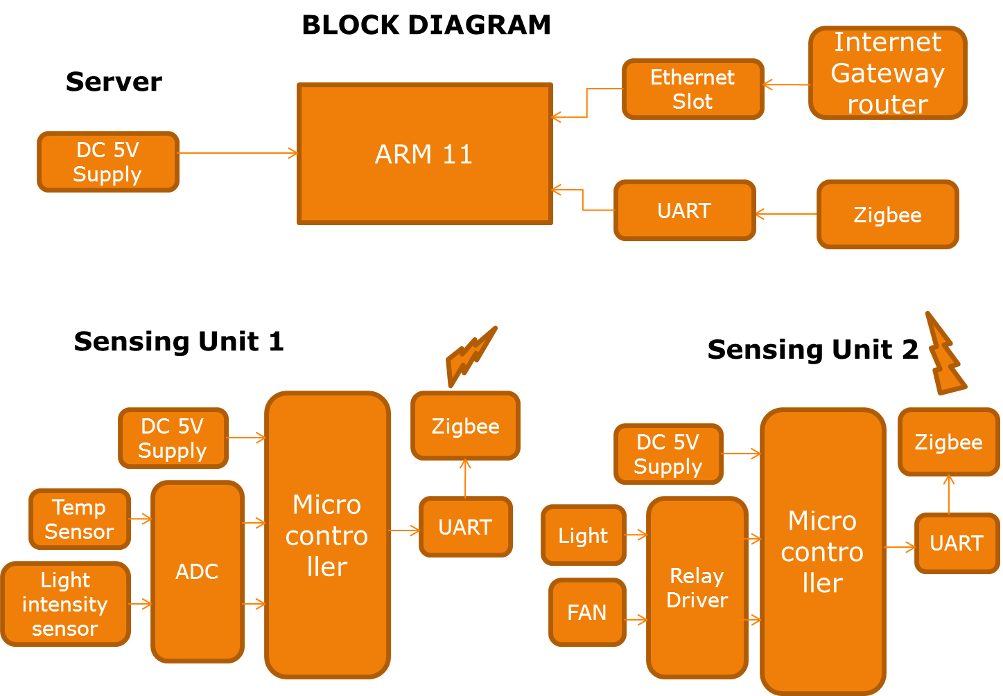

Hardware:
Raspberry pi Board (ARM 11), Ethernet Router, Zigbee Modules, 8051 Controller Boards, Temperature Sensor, Humidity Sensor, Light, Fan.
Software:
Embedded Linux OS, Ethernet Protocol, Qtopia GUI
Applications:
Industry, Airports
Advantages: Low Cost, Easy to Install and operate

